Chapter 9

Advance Architectures

- RISIC and CISC Fundamentals
- Instruction Pipeline, Register Window
- Flynn’s Taxonomy, MIMD system topologies and architectures
- Introduction to multicore architecture

RISC and CISC Fundamentals

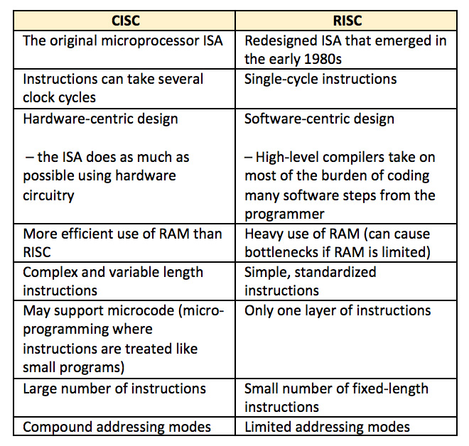

Instruction Pipeline, Register Window

Pipelining is a process of arrangement of hardware elements of the CPU such that its overall performance is increased. Simultaneous execution of more than one instruction takes place in a pipelined processor.

Let us see a real life example that works on the concept of pipelined operation. Consider a water bottle packaging plant. Let there be 3 stages that a bottle should pass through, Inserting the bottle(I), Filling water in the bottle(F), and Sealing the bottle(S). Let us consider these stages as stage 1, stage 2 and stage 3 respectively. Let each stage take 1 minute to complete its operation.
Now, in a non-pipelined operation, a bottle is first inserted in the plant, after 1 minute it is moved to stage 2 where water is filled. Now, in stage 1 nothing is happening. Similarly, when the bottle moves to stage 3, both stage 1 and stage 2 are idle. But in pipelined operation, when the bottle is in stage 2, another bottle can be loaded at stage 1. Similarly, when the bottle is in stage 3, there can be one bottle each in stage 1 and stage 2. So, after each minute, we get a new bottle at the end of stage 3. Hence, the average time taken to manufacture 1 bottle is :

Without pipelining = 9/3 minutes = 3m
I F S | | | | | |
| | | I F S | | |
| | | | | | I F S (9 minutes)
With pipelining = 5/3 minutes = 1.67m
I F S | |
| I F S |
| | I F S (5 minutes)
Thus, pipelined operation increases the efficiency of a system.
Design of a basic pipeline
- In a pipelined processor, a pipeline has two ends, the input end and the output end. Between these ends, there are multiple stages/segments such that output of one stage is connected to input of next stage and each stage performs a specific operation.
- Interface registers are used to hold the intermediate output between two stages. These interface registers are also called latch or buffer.
- All the stages in the pipeline along with the interface registers are controlled by a common clock.

Execution in a pipelined processor
Execution sequence of instructions in a pipelined processor can be visualized using a space-time diagram. For example, consider a processor having 4 stages and let there be 2 instructions to be executed. We can visualize the execution sequence through the following space-time diagrams:

Non overlapped execution:
STAGE / CYCLE | 1 | 2 | 3 | 4 | 5 | 6 | 7 | 8
S1 | I₁ |  |  |  | I₂
S2 |  | I₁ |  |  |  | I₂
S3 |  |  | I₁ |  |  |  | I₂
S4 |  |  |  | I₁ |  |  |  | I₂
Total time = 8 Cycle

Overlapped execution:
STAGE / CYCLE | 1 | 2 | 3 | 4 | 5
S1 | I₁ | I₂
S2 |  | I₁ | I₂
S3 |  |  | I₁ | I₂
S4 |  |  |  | I₁ | I₂
Total time = 5 Cycle

Pipeline Stages
RISC processor has 5 stage instruction pipeline to execute all the instructions in the RISC instruction set. Following are the 5 stages of RISC pipeline with their respective operations:
- Stage 1 (Instruction Fetch)
In this stage the CPU reads instructions from the address in the memory whose value is present in the program counter.
- Stage 2 (Instruction Decode)
In this stage, instruction is decoded and the register file is accessed to get the values from the registers used in the instruction.
- Stage 3 (Instruction Execute)
In this stage, ALU operations are performed.
- Stage 4 (Memory Access)
In this stage, memory operands are read and written from/to the memory that is present in the instruction.
- Stage 5 (Write Back)
In this stage, computed/fetched value is written back to the register present in the instructions.

Performance of a pipelined processor
Consider a ‘k’ segment pipeline with clock cycle time as ‘Tp’. Let there be ‘n’ tasks to be completed in the pipelined processor. Now, the first instruction is going to take ‘k’ cycles to come out of the pipeline but the other ‘n – 1’ instructions will take only ‘1’ cycle each, i.e, a total of ‘n – 1’ cycles. So, time taken to execute ‘n’ instructions in a pipelined processor:
ET_{pipeline} = k + n – 1 cycles
= (k + n – 1) T_{p}
In the same case, for a non-pipelined processor, execution time of ‘n’ instructions will be:
ET_{non-pipeline} = n * k * T_{p}
So, speedup (S) of the pipelined processor over non-pipelined processor, when ‘n’ tasks are executed on the same processor is:
S = Performance of pipelined processor /
Performance of Non-pipelined processor
As the performance of a processor is inversely proportional to the execution time, we have,
S = ET_{non-pipeline} / ET_{pipeline}
=> S = [n * k * T_{p}] / [(k + n – 1) * T_{p}]
S = [n * k] / [k + n – 1]
When the number of tasks ‘n’ are significantly larger than k, that is, n >> k
S = n * k / n
S = k
Where ‘k’ are the number of stages in the pipeline.
Also, Efficiency = Given speed up / Max speed up = S / S_{max}
We know that, S_{max} = k
So, Efficiency = S / k

Throughput = Number of instructions / Total time to complete the instructions
So, Throughput = n / (k + n – 1) * Tp

Note: The cycles per instruction (CPI) value of an ideal pipelined processor is 1

Conflicts in Instruction Pipelining and their Solutions
Dependencies in a pipelined processor
There are mainly three types of dependencies possible in a pipelined processor. These are:
1) Structural Dependency
2) Control Dependency
3) Data Dependency
These dependencies may introduce stalls in the pipeline.
Stall: A stall is a cycle in the pipeline without new input.
Structural dependency
This dependency arises due to the resource conflict in the pipeline. A resource conflict is a situation when more than one instruction tries to access the same resource in the same cycle. A resource can be a register, memory, or ALU.
Example:
INSTRUCTION / CYCLE | 1 | 2 | 3 | 4 | 5
I₁ | IF(Mem) | ID | EX | Mem
I₂ |  | IF(Mem) | ID | EX
I₃ |  |  | IF(Mem) | ID | EX
I₄ |  |  |  | IF(Mem) | ID

In the above scenario, in cycle 4, instructions I₁ and I₄ are trying to access same resource (Memory) which introduces a resource conflict.
To avoid this problem, we have to keep the instruction on wait until the required resource (memory in our case) becomes available. This wait will introduce stalls in the pipeline as shown below:
CYCLE | 1 | 2 | 3 | 4 | 5 | 6 | 7 | 8
I₁ | IF(Mem) | ID | EX | Mem | WB
I₂ |  | IF(Mem) | ID | EX | Mem | WB
I₃ |  |  | IF(Mem) | ID | EX | Mem | WB
I₄ |  |  |  | – | – | – | IF(Mem)
Solution for structural dependency
To minimize structural dependency stalls in the pipeline, we use a hardware mechanism called Renaming.
Renaming: According to renaming, we divide the memory into two independent modules used to store the instruction and data separately called Code memory(CM) and Data memory(DM) respectively. CM will contain all the instructions and DM will contain all the operands that are required for the instructions.

INSTRUCTION/ CYCLE | 1 | 2 | 3 | 4 | 5 | 6 | 7
I₁ | IF(CM) | ID | EX | DM | WB
I₂ |  | IF(CM) | ID | EX | DM | WB
I₃ |  |  | IF(CM) | ID | EX | DM | WB
I₄ |  |  |  | IF(CM) | ID | EX | DM
I₅ |  |  |  |  | IF(CM) | ID | EX
I₆ |  |  |  |  |  | IF(CM) | ID
I₇ |  |  |  |  |  |  | IF(CM)
Control Dependency (Branch Hazards)
This type of dependency occurs during the transfer of control instructions such as BRANCH, CALL, JMP, etc. On many instruction architectures, the processor will not know the target address of these instructions when it needs to insert the new instruction into the pipeline. Due to this, unwanted instructions are fed to the pipeline.
Consider the following sequence of instructions in the program:
100: I₁
101: I₂ (JMP 250)
102: I₃
.
.
250: BI₁
Expected output$: I1 → I2 → BI1$
NOTE: Generally, the target address of the JMP instruction is known after ID stage only.
INSTRUCTION/ CYCLE | 1 | 2 | 3 | 4 | 5 | 6
I₁ | IF | ID | EX | MEM | WB
I₂ |  | IF | ID (PC:250) | EX | Mem | WB
I₃ |  |  | IF | ID | EX | Mem
BI₁ |  |  |  | IF | ID | EX
Output Sequence: $I1 → I2→ I3 → BI1$

So, the output sequence is not equal to the expected output that means the pipeline is not implemented correctly.
To correct the above problem we need to stop the Instruction fetch until we get target address of branch instruction. This can be implemented by introducing delay slot until we get the target address.
INSTRUCTION/ CYCLE | 1 | 2 | 3 | 4 | 5 | 6
I₁ | IF | ID | EX | MEM | WB
I₂ |  | IF | ID (PC:250) | EX | Mem | WB
Delay | – | – | – | – | – | –
BI₁ |  |  |  | IF | ID | EX

Output Sequence: $I1 → I2 → Delay (Stall) → BI1$
As the delay slot performs no operation, this output sequence is equal to the expected output sequence. But this slot introduces stall in the pipeline.
Solution for Control dependency Branch Prediction is the method through which stalls due to control dependency can be eliminated. In this at 1st stage prediction is done about which branch will be taken. For branch prediction Branch penalty is zero.

Branch penalty: The number of stalls introduced during the branch operations in the pipelined processor is known as branch penalty.

NOTE: As we see that the target address is available after the ID stage, so the number of stalls introduced in the pipeline is 1. Suppose, the branch target address would have been present after the ALU stage, there would have been 2 stalls. Generally, if the target address is present after the k^{th} stage, then there will be (k – 1) stalls in the pipeline.
Total number of stalls introduced in the pipeline due to branch instructions = Branch frequency * Branch Penalty

Data Dependency (Data Hazard)
Let us consider an ADD instruction S, such that
S : ADD R1, R2, R3
Addresses read by S = I(S) = {R2, R3}
Addresses written by S = O(S) = {R1}

Now, we say that instruction S2 depends in instruction S1, when

This condition is called Bernstein condition.
Three cases exist:
- Flow (data) dependence: O(S1) ∩ I (S2), S1 → S2 and S1 writes after something read by S2
- Anti-dependence: I(S1) ∩ O(S2), S1 → S2 and S1 reads something before S2 overwrites it
- Output dependence: O(S1) ∩ O(S2), S1 → S2 and both write the same memory location.
Example: Let there be two instructions I1 and I2 such that:
I1 : ADD R1, R2, R3
I2 : SUB R4, R1, R2
When the above instructions are executed in a pipelined processor, then data dependency condition will occur, which means that I₂ tries to read the data before I₁ writes it, therefore, I₂ incorrectly gets the old value from I₁.
INSTRUCTION / CYCLE | 1 | 2 | 3 | 4
I₁ | IF | ID | EX | DM
I₂ |  | IF | ID(Old value) | EX

To minimize data dependency stalls in the pipeline, operand forwarding is used.
Operand Forwarding: In operand forwarding, we use the interface registers present between the stages to hold intermediate output so that dependent instruction can access new value from the interface register directly.

Considering the same example:
I1 : ADD R1, R2, R3
I2 : SUB R4, R1, R2
INSTRUCTION / CYCLE | 1 | 2 | 3 | 4
I₁ | IF | ID | EX | DM
I₂ |  | IF | ID | EX
Data Hazards
Data hazards occur when instructions that exhibit data dependence, modify data in different stages of a pipeline. Hazard cause delays in the pipeline. There are mainly three types of data hazards:

1) RAW (Read after Write) [Flow/True data dependency]
2) WAR (Write after Read) [Anti-Data dependency]
3) WAW (Write after Write) [Output data dependency]

Let there be two instructions I and J, such that J follow I. Then,
- RAW hazard occurs when instruction J tries to read data before instruction I writes it.
Eg:
I: $R2 ← R1 + R3$
J: $R4 ← R2 + R3$
- WAR hazard occurs when instruction J tries to write data before instruction I reads it.
Eg:
I:$R2 ←R1 + R3$
J: $R3 ←R4 + R5$
- WAW hazard occurs when instruction J tries to write output before instruction I writes it.
Eg:
I: $R2 ← R1 + R3$
J: $R2 ← R4 + R5$
WAR and WAW hazards occur during the out-of-order execution of the instructions.

Register Window
In some RISC microarchitectures there are less registers shared between the program - “global registers” and each function gets a set of registers “window” that it has permission to use.
The idea is restrict each scope of the program to certain registers - a certain “window”. The window includes registers for local use, registers to hold the parameters from the previous function, and registers to hold parameters for the next function.
Each scope is denied access to all but the global, local, and parent-child i/o registers. The parent and child input/output registers are the registers that “overlap”.

Flynn’s Taxonomy, MIMD system topologies and architectures
Parallel computing is a computing where the jobs are broken into discrete parts that can be executed concurrently. Each part is further broken down to a series of instructions. Instructions from each part execute simultaneously on different CPUs. Parallel systems deal with the simultaneous use of multiple computer resources that can include a single computer with multiple processors, a number of computers connected by a network to form a parallel processing cluster or a combination of both.
Parallel systems are more difficult to program than computers with a single processor because the architecture of parallel computers varies accordingly and the processes of multiple CPUs must be coordinated and synchronized.
The crux of parallel processing are CPUs. Based on the number of instruction and data streams that can be processed simultaneously, computing systems are classified into four major categories:
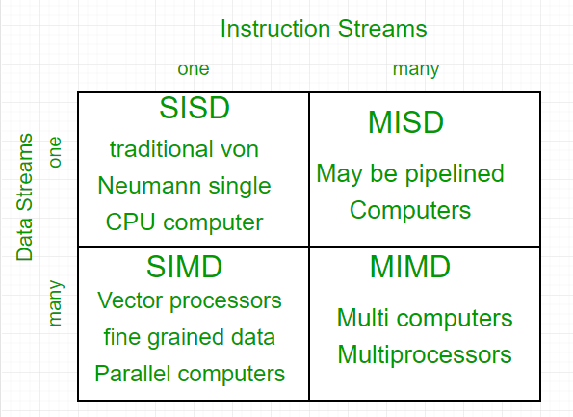

Flynn’s classification
- Single-instruction, single-data (SISD) systems –
An SISD computing system is a uniprocessor machine which is capable of executing a single instruction, operating on a single data stream. In SISD, machine instructions are processed in a sequential manner and computers adopting this model are popularly called sequential computers. Most conventional computers have SISD architecture. All the instructions and data to be processed have to be stored in primary memory.
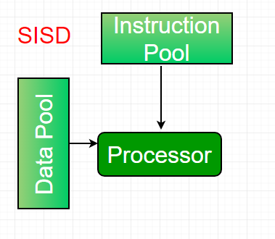
The speed of the processing element in the SISD model is limited(dependent) by the rate at which the computer can transfer information internally. Dominant representative SISD systems are IBM PC, workstations.
- Single-instruction, multiple-data (SIMD) systems –
An SIMD system is a multiprocessor machine capable of executing the same instruction on all the CPUs but operating on different data streams. Machines based on an SIMD model are well suited to scientific computing since they involve lots of vector and matrix operations. So that the information can be passed to all the processing elements (PEs) organized data elements of vectors can be divided into multiple sets(N-sets for N PE systems) and each PE can process one data set.
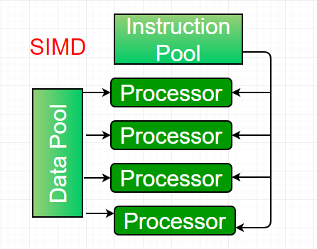
Dominant representative SIMD systems is Cray’s vector processing machine.
- Multiple-instruction, single-data (MISD) systems –
An MISD computing system is a multiprocessor machine capable of executing different instructions on different PEs but all of them operating on the same dataset .
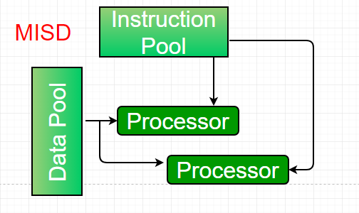
Example $Z = sin(x)+cos(x)+tan(x)$
The system performs different operations on the same data set. Machines built using the MISD model are not useful in most of the application, a few machines are built, but none of them are available commercially.
- Multiple-instruction, multiple-data (MIMD) systems –
An MIMD system is a multiprocessor machine which is capable of executing multiple instructions on multiple data sets. Each PE in the MIMD model has separate instruction and data streams; therefore machines built using this model are capable to any kind of application. Unlike SIMD and MISD machines, PEs in MIMD machines work asynchronously.
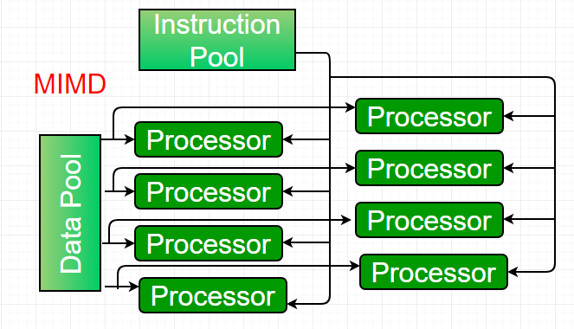
MIMD machines are broadly categorized into shared-memory MIMD and distributed-memory MIMD based on the way PEs are coupled to the main memory.
In the shared memory MIMD model (tightly coupled multiprocessor systems), all the PEs are connected to a single global memory and they all have access to it. The communication between PEs in this model takes place through the shared memory, modification of the data stored in the global memory by one PE is visible to all other PEs. Dominant representative shared memory MIMD systems are Silicon Graphics machines and Sun/IBM’s SMP (Symmetric Multi-Processing).
In Distributed memory MIMD machines (loosely coupled multiprocessor systems) all PEs have a local memory. The communication between PEs in this model takes place through the interconnection network (the inter process communication channel, or IPC). The network connecting PEs can be configured to tree, mesh or in accordance with the requirement.
The shared-memory MIMD architecture is easier to program but is less tolerant to failures and harder to extend with respect to the distributed memory MIMD model. Failures in a shared-memory MIMD affect the entire system, whereas this is not the case of the distributed model, in which each of the PEs can be easily isolated. Moreover, shared memory MIMD architectures are less likely to scale because the addition of more PEs leads to memory contention. This is a situation that does not happen in the case of distributed memory, in which each PE has its own memory. As a result of practical outcomes and user’s requirement, distributed memory MIMD architecture is superior to the other existing models.

Interconnection Structure in Multiprocessor
CPUs, TOPs connect’ to input-output device, and a memory unit form a multiprocessor system, they may be partitioned into a number of separate modules. The interconnection between the components can have different physical configurations, depending on the number of transfer paths that are available between the processors and memory in a shared memory system or among the processing elements in a loosely coupled system. There are several physical forms available for establishing an interconnection network. Some of them are:
- Time-shared common bus
- Multiport memory
- Crossbar switch
- Multistage switching network
- Hypercube network
Time Shared Common Bus
- A common-bus multiprocessor system consists of a number of processors connected through a common path to a memory unit.
- Disadvantages :
- Only one processor can communicate with the memory or another processor at any given time.
- As a consequence, the total overall transfer rate within the system is limited by the speed of the single path
- A more economical implementation of a dual bus structure is depicted in Fig. below.
- Part of the local memory may be designed as a cache memory attached to the CPU.
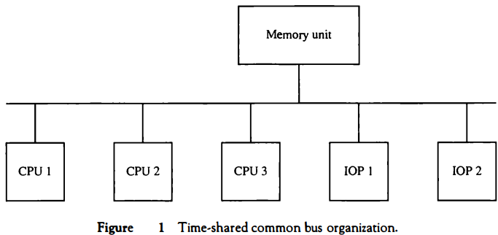

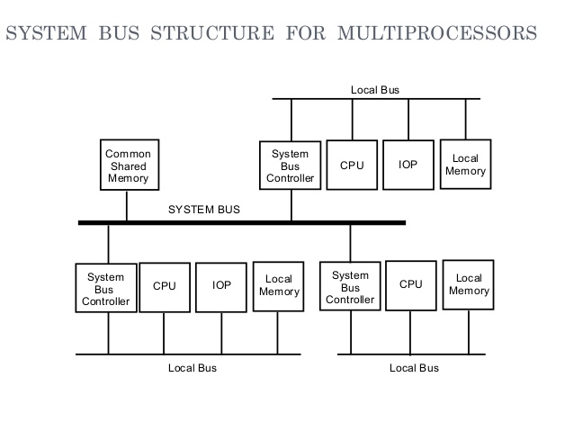
Fig: System bus structure for multiprocessors

Multiport Memory
- A multiport memory system employs separate buses between each memory module and each CPU.
- The module must have internal control logic to determine which port will have access to memory at any given time.
- Memory access conflicts are resolved by assigning fixed priorities to each memory port.
- Advantages
- The high transfer rate can be achieved because of the multiple paths.
- Disadvantages
- It requires expensive memory control logic and a large number of cables and connections.
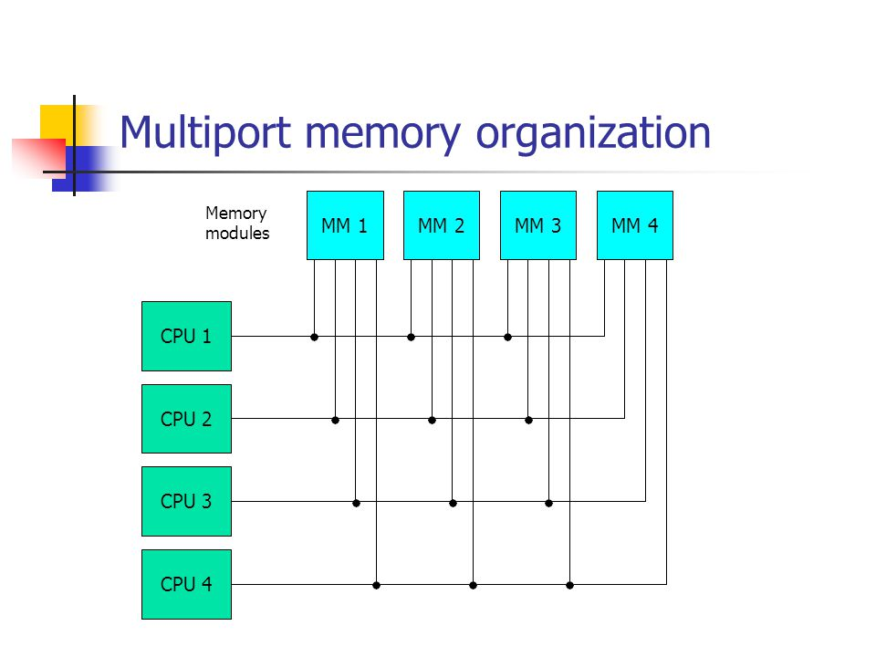
Fig: Multiport organization

Crossbar Switch
- Consists of a number of crosspoints that are placed at intersections between processor buses and memory module paths.
- The small square in each crosspoint is a switch that determines the path from a processor to a memory module.
- Advantage
- Supports simultaneous transfers from all memory modules
- Disadvantage
- The hardware required to implement the switch can become quite large and complex.
- Below fig. shows the functional design of a crossbar switch connected to one memory module.

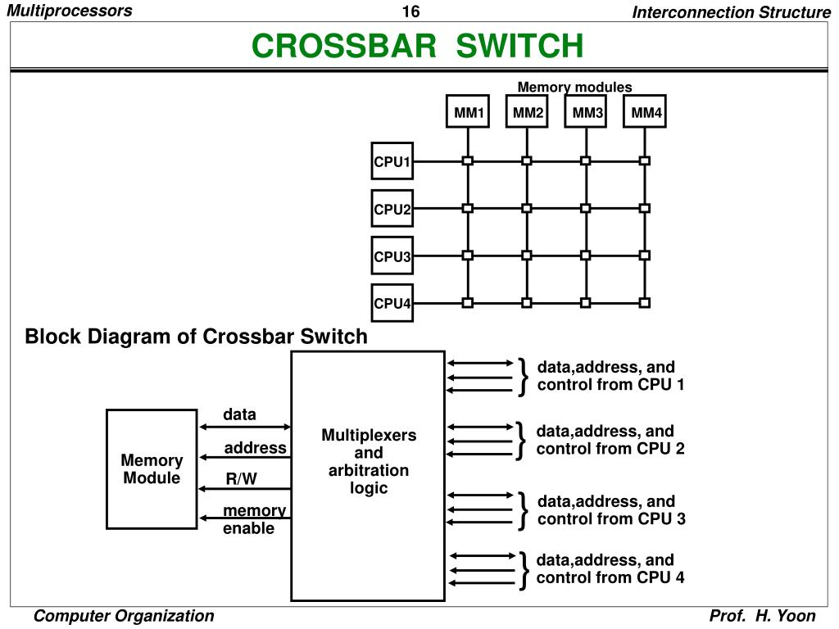
Multistage Switching Network

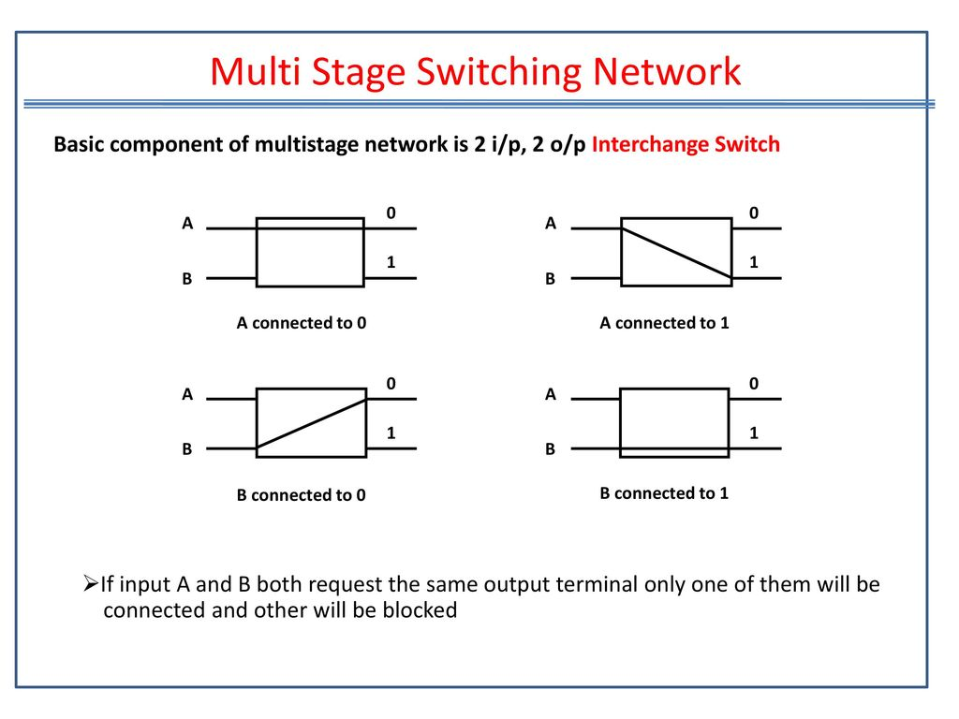
- The basic component of a multistage network is a two-input, two-output interchange switch as shown in Fig. below.

- One such topology is the omega switching network shown in Fig. below

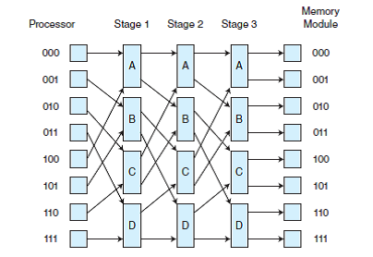
Hypercube System
- The hypercube or binary n-cube multiprocessor structure is a loosely coupled system composed of N=2n processors interconnected in an n-dimensional binary cube.
- Each processor forms a node of the cube, in effect it contains not only a CPU but also local memory and I/O interface.
- Each processor address differs from that of each of its n neighbors by exactly one bit position.
- Fig. below shows the hypercube structure for n=1, 2, and 3.
- Routing messages through an n-cube structure may take from one to n links from a source node to a destination node.
- A routing procedure can be developed by computing the exclusive-OR of the source node address with the destination node address.
- The message is then sent along any one of the axes that the resulting binary value will have 1 bits corresponding to the axes on which the two nodes differ.
- A representative of the hypercube architecture is the Intel iPSC computer complex.
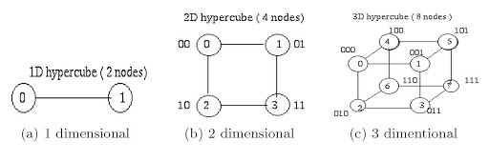
- It consists of 128(n=7) microcomputers, each node consists of a CPU, a floating-point processor, local memory, and serial communication interface units.

Introduction to multicore architecture
The main variables in a multicore organization are as follows:
- The number of core processors on the chip.
- The number of levels of cache memory.
- The amount of cache memory that is shared

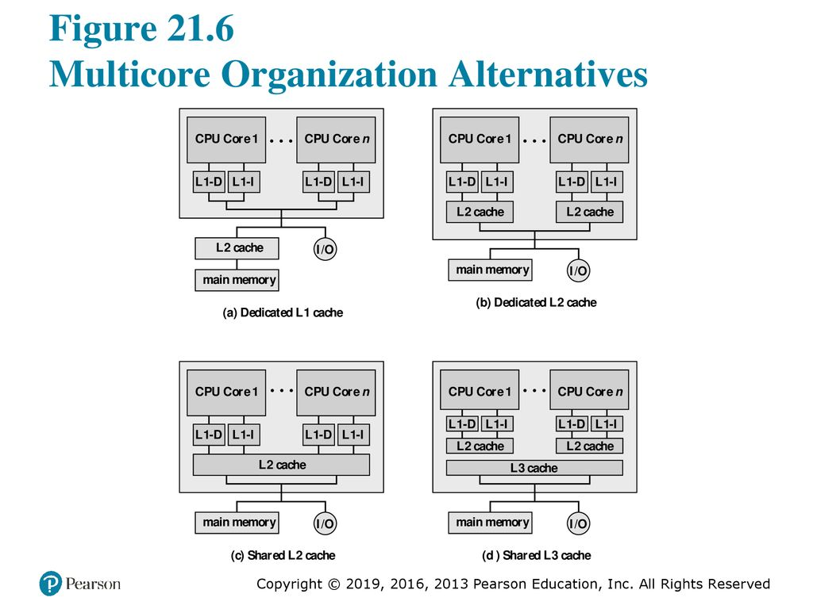
General Organization of Multicore Systems

Figure (a) shows an organization found in some of the earlier multicore computer chips and is still seen in embedded chips. In this organization, the only on-chip cache is L1 cache, each core having its own dedicated L1 cache. Almost invariably, the L1 cache is divided into instruction and data caches. An example of this organization is the ARM11 MP core.
Figure (b) is the organization in which there is no on-chip cache sharing. In this, there is enough area available on the chip to allow for L2 cache. An example of this organization is AMD Opteron.
Figure (c) shows allocation of chip space to memory, but with the use of a shared L2 cache. Intel Core Duo has this organization.
The amount of cache memory available on the chip continues to grow, performance considerations to grow, performance considerations dictate splitting off a separate, shared L3 cache with dedicated L1 and L2 cache for each core processor. Intel core i7 is an example of shared L3 cache organization.
Benefits of the shared cache architecture
- Efficient usage of the last-level cache If one core idles, the other core takes all the shared cache
- Reduces resource underutilization
- Allows more data-sharing opportunities for threads running on separate cores that are sharing cache
- One core can pre-/post-process data for the other core
- Alternative communication mechanisms between cores
- Reduce cache-coherency complexity
- Reduced false sharing because of the shared cache
- Less workload to maintain coherency, compared to the private cache architecture
- The same data only needs to be stored once
- Effective data sharing between cores allows data requests to be resolved at the shared-cache level instead of going all the way to the system memory

